A1: Contemporaneous zero restrictions or the LR neutrality restriction. Please see handwritten notes Lecture 1.

A2:
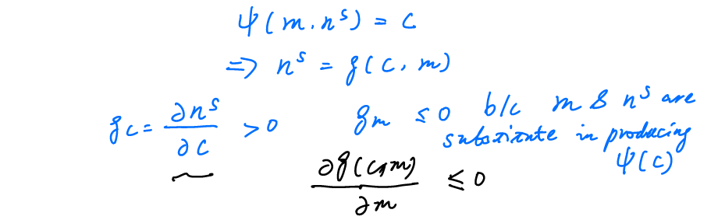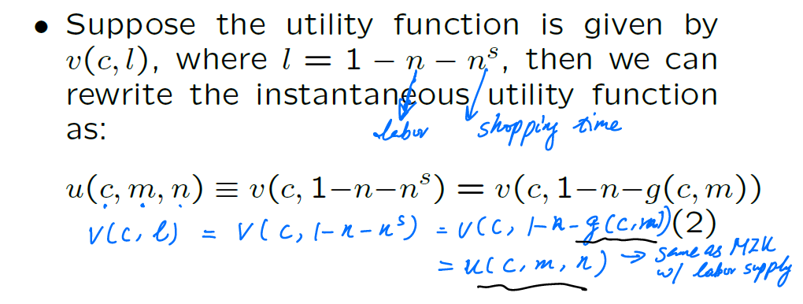
Also, we can relate the sign of U_{cm} to the production function of $\phi $ and the utility function.
